CodSoft Internship

1. TASK 1

Mobile App Signup Flow

A mobile app signup flow is the process of users creating an account and signing up for an

app. The goal of a good signup flow is to make it easy and quick for users to sign up, while

also collecting the necessary information from them.

Short and sweet: Users are more likely to complete a signup flow if it is short and easy to

follow.

Personalized: The more personalized the signup flow is, the more likely users are to

complete it. You can personalize the experience by using the user's name, location, or

interests.

Useful: The signup flow should collect the necessary information from users, but it should

not ask for too much information.

Error-free: The signup flow should be free of errors, so that users do not have to repeat the

process.

Secure: The signup flow should be secure, so that users' personal information is protected.

LinkedIn link

https://www.linkedin.com/posts/krupa-jethwa-99754725b_codsoft-internship-uiuxdesign-activity-7241673302904066048-zN45?utm_source=share&utm_medium=member_android

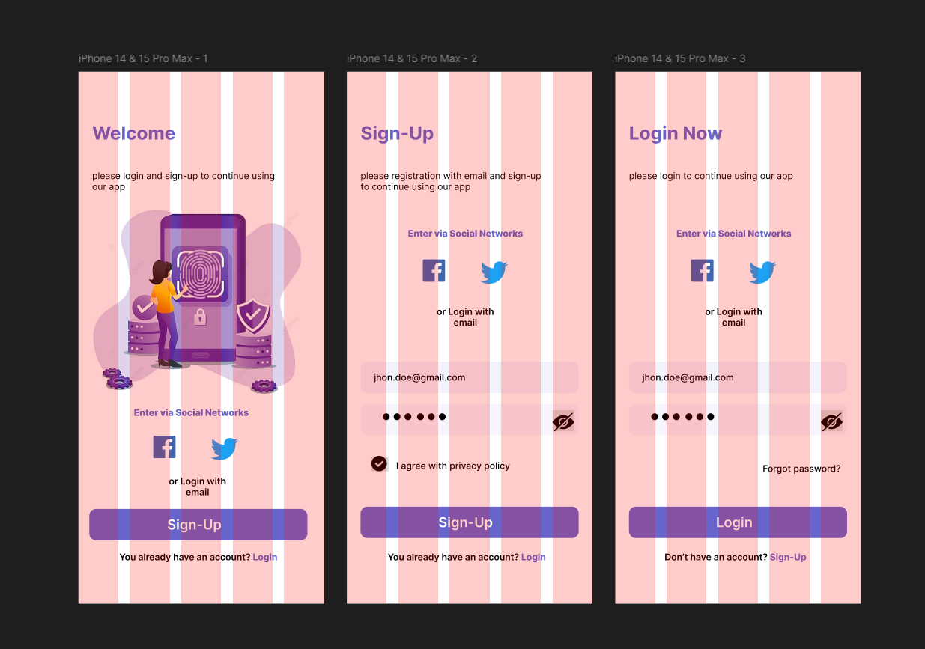

2. TASK 2

Email Template

An email template is a pre-designed email that can be used to send out

marketing or promotional emails. The goal of a good email template is to make it

easy and quick for businesses to send out emails that look professional and

engaging.

FOR DEMO CLICK HERE

Visually appealing: The email template should be visually appealing and easy to read. The

use of colors, fonts, and images should be carefully considered to create a visually

appealing email.

Easy to use: The email template should be easy to use and navigate. The user should be able

to easily find the necessary information and make changes to the template.

Responsive: The email template should be responsive, so that it looks good on all devices,

including desktop computers, laptops, tablets, and smartphones.

LinkedIN link

https://www.linkedin.com/posts/krupa-jethwa-99754725b_uiuxdesign-figmadesign-codsoftinternship-activity-7245317700229484546-Wtlk?utm_source=share&utm_medium=member_android

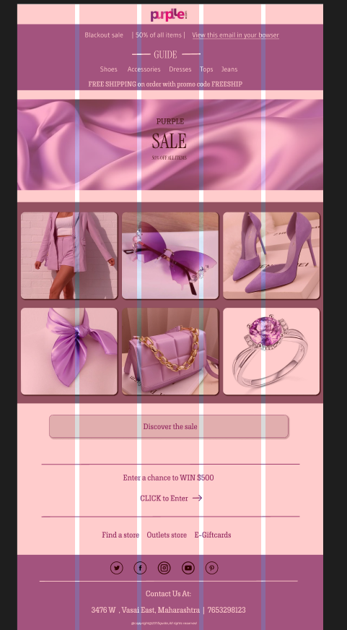

3. TASK 3

Restaurant menu

A restaurant menu UI/UX project is the process of designing a menu that is

both visually appealing and easy to use. The goal of a good restaurant menu

is to make it easy for customers to find the dishes they want, and to

encourage them to order more.

FOR DEMO CLICK HERE

Visually appealing: The menu should be visually appealing and easy to read. The use of

colors, fonts, and images should be carefully considered to create a visually appealing

menu.

Easy to use: The menu should be easy to use and navigate. The customer should be able to

easily find the necessary information and make their selections.

Categorized: The menu should be categorized, so that customers can easily find the dishes

they are looking for. The categories should be clear and concise, and they should be

consistent throughout the menu.

Linkedin link

https://www.linkedin.com/posts/krupa-jethwa-99754725b_uiuxdesign-figmadesign-codsoftinternship-activity-7245719631183630336-J-U6?utm_source=share&utm_medium=member_android

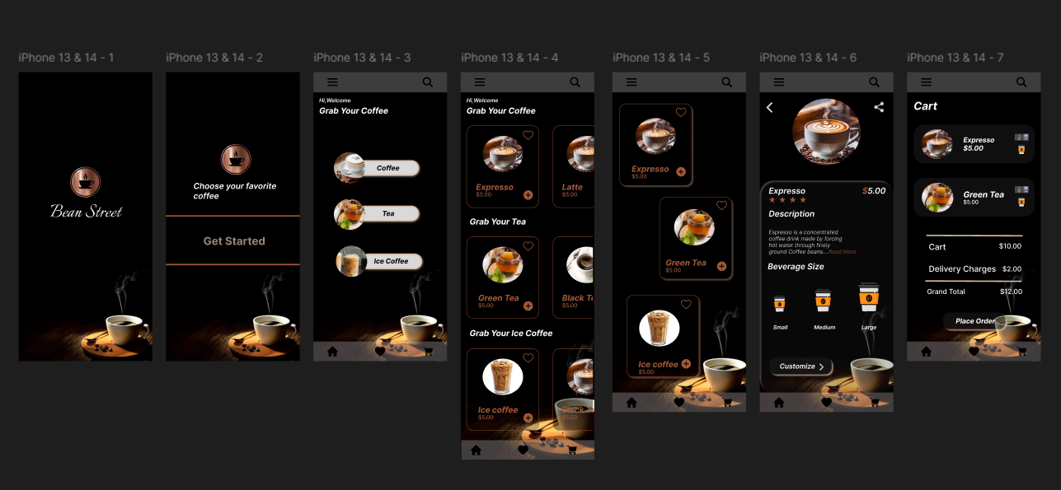

4. TASK 4

E-commerce website

An e-commerce website UI/UX project is the process of designing an online

store that is both visually appealing and easy to use. The goal of a good e-

commerce website is to make it easy for customers to find the products

they want, and to encourage them to buy them.

FOR DEMO CLICK HERE

Visually appealing: The website should be visually appealing and easy to read. The use of colors,

fonts, and images should be carefully considered to create a visually appealing website.

Easy to use: The website should be easy to use and navigate. The customer should be able to easily

find the necessary information and make their purchases.

Categorized; The products on the website should be categorized, so that customers can easily find

the products they are looking for. The categories should be clear and concise, and they should be

consistent throughout the website.

Searchable: The website should be searchable so that customers can easily find the products they

are looking for. The search function should be easy to use and should return relevant results.

Linkedin link

